**Exhaustive Analysis of Indian Agriculture Sector Using Power BI**

**Week 1 – ETL**

**ETL:** ETL stands for Extract Transform and Load, here we perform the three operations on the data that we import from data sources.

**Data Sources:** Data sources are the places we can get data from, this can be excel files, csv files, databases and even websites/web.

**Views:** There are three views that we can choose from;

**Report View:** This view is used for visualizations

**Table View:** This view is used for viewing the data as a table

**Model View:** This view is used to understand relationships between data.

**Step 1: Loading the Data**

Load the data; To do this, we open PowerBI Desktop and using the “Get Data” button from the home tab we import the Exhaustive Analysis of Indian Agriculture.csv file

Once we see this window we hit on the “Load” button as we don’t want to do any transformations right now but later.

**Step 2: Cleaning/Transforming the Data**

Now that we didn’t perform any transformations earlier, we do it now, using the “Transform Data” button in the home tab.

Once we click on that button, a new window “Power Query Editor” opens. This is the main part which performs all the required transformations.

Now inside of this Power Query Editor, we can clean our data. Here we do this by getting rid of all the “NULL” values or cleaning empty rows/columns. To do this, we just select the row/column we want to remove, right click on it and hit remove.

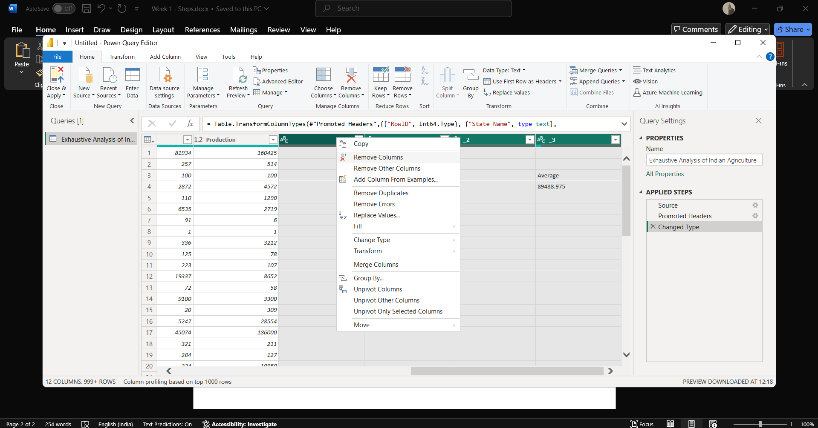

**Step 3: Check if there are more NULL values**

We’ve gotten rid of empty/useless columns now finally we want to verify that everything is correct and there are no issues, to do this we have to enable an option which gives us even more information about our data.

Head over to the View tab from the Home tab and check the value “Column Quality” this shows us the quality of each column and helps us understand them better

Once we check that option, we will be able to see more information about each column like this;

Now each column shows us their Error and Empty percentage, but here they’re all zero that means we don’t need to do anymore transformations and we can apply the changes.

To do that; find the button and click on close and apply to save the changes and close the window

**Result:**

This will give us data that does not have any useless values and no NULL values, that means the cleaning of the data has been completed.

